MEDICAL HISTORY
Date:_________________
Name:_________________________________
Date of Birth: ____________________ Age:_______ Occupation:_______________________________
Marital Status (circle one): Single Married Divorced Widowed Separated

Rate pain level (0 – 10) at its:
Current______ Best ______ Worst______
Date of onset of pain: _________________
Improving/worsening/unchanging
Describe how your pain began: ____________________________________________________________________________________________________________________________________________________________

Please mark location of pain
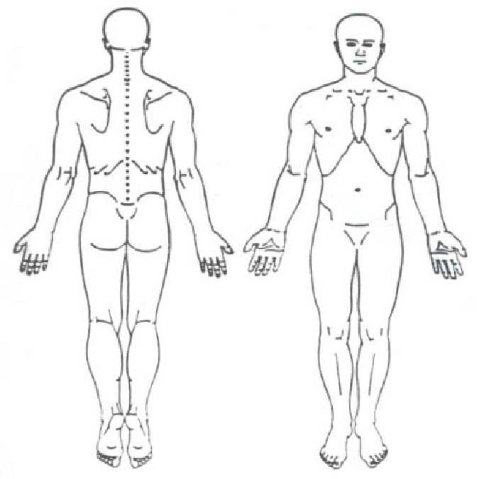

How would you describe your pain?

- Burning
- Cramping
- Pins and needles
- Sharp
- Numbness
- Shooting
- Dull, aching
- Throbbing
- Electric- like
- Pressure
- Other _______

How do the following affect your pain?
 | Better | Worse | No affect
Lying down
Standing
Sitting
Walking
Exercise
Morning
Evening
When still
On the move

Have you had any changes to your bowel or bladder function since start of pain? Yes _____ No ______
Have you had physical or occupational therapy for your pain this year? Yes ______ No ______

OVER

How does your pain interfere with the following activities?
Activity | Does not interfere | Occasionally interferes | Often interferes | Completely interferes
Going to work
Household chores
Stairs
Recreational activity
Driving
Sleeping
Bathing
Getting dressed

Have you had any falls in the past year? No___ Yes___ If yes, how many? ___

Do you have history of (circle all that apply): Head trauma Whiplash Temporal Mandibular Joint (TMJ) dysfunction

Personal Medical History (check if yes)

- Cancer
- Arthritis
- High blood pressure
- Congestive heart failure
- Pulmonary disease
- Heart attack
- Stroke
- Diabetes
- Glaucoma
- Macular degeneration
- Depression
- Autoimmune disease_________

Past Surgeries: _____________________________________________________________________________________
Medications (list or provide a copy): ____________________________________________________________________
Allergies: __________________________________________________________________________________________

At Peak, we are committed to helping you achieve whole body wellness. The following questions pertain to your general health and level of well-being:

How many days per week (avg) do you engage in moderate to vigorous physical activity (brisk walk)? ______ days
How many minutes (avg) do you engage in physical activity at this level? _______ minutes
How many days a week do you perform strengthening exercises (bodyweight or resistance training)? ______ days

How much of the time during the past 4 weeks…
 | All of the time | Most of the time | A good bit of the time | Some of the time | A little of the time | None of the time
Did you eat a diet with 5 or more servings of fruit and vegetables (in a day)
Have you felt stressed or anxious
Did you awake feeling rested
Has your physical or emotional status interfered with your social activities
Used tobacco products
Consumed alcohol
I am interested in achieving optimal wellness to help prevent future injuries and illnesses. Please provide me with more information on (check all that apply)…
- Nutrition
- Stress Management
- Tobacco or Alcohol cessation
- Quality Sleep
- Physical Fitness
- Emotional Well-being

